On 30 September, in the event Labelab Ravenna in 2010 was held the workshop "DISPOSAL OF THE ADRIATIC OFFSHORE PLATFORMS: AN OPPORTUNITY 'FOR THE PROTECTION OF NATURE AND THE COASTAL TOURISM".

Organized by dr. Luca Vignoli, PADI Instructor, He proposed the idea of using the Adriatic offshore platforms ENI in decommissioning posing them on the seabed (sinking) in order to create a series of hot spots of marine biodiversity and coastal tourism sites accessible to the divers.

At the workshop partecipated as Speakers:
- Ing. Renzo Piantoni ENI div. Exploration & Production,
- Dr. Attilio Rinaldi, ex Director of ICRAM -Italian National Research Center for Marine Environment-
- Dr. Giovanni Fucci president of Paguro Association
- Dr. Roberto Raffaelli for PADI.

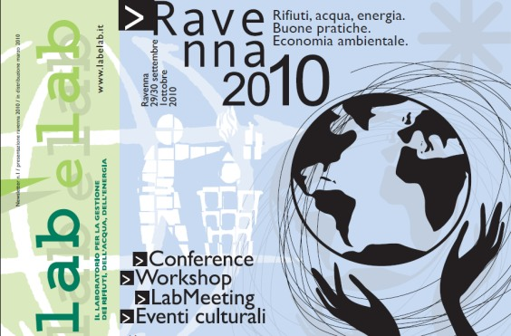

Like giant metal iceberg emerge from the water, the so-called "islands of iron", offshore platforms for the extraction of hydrocarbons in the sea. Invaluable source of wealth during the period of activity, since ferrous clusters when the deposit is exhausted. And then what is their fate?

Along the Italian Adriatic Sea coast actually there are about 80 active methanifer offshore platforms, including 50 in front of Ravenna and Rimini.

There would be different possible solutions to dispose these imposing technological structures, like for example:

- possible risks to humans or to the environment,
- land transportation and dismantlement,
- conversion into luxury off-shore marine hotels,
- wind-parks,
- underwater oasis for marine biology and coastal tourism recovery .

But for dr. Vignoli the solution more cost-effective, but also environmentally better, is just one: sink them.

The idea, explained in detail in Eni, - freely downloadable from the site www.lucavignoli.it - starts by the following consideration: properly reclaimed, sunken platforms do not pollute, but instead become "hot spots of biological diversity"; true oases of biological marine repopulating, auto-protected from fishing nets and underwater paradise for diving tourists.

By law, Eni, once the mining ended, is required to reclaim the mining sites and to dispose of disused platforms. At the moment this means only one thing: backing on the ground to be dismantled. A complex and very costly operation..

How we said, there are a lot of different proposed alternatives of various kinds: from installation of wind turbines on up even to build upon the luxury hotels. … But sinking them would instead make available a permanent solid substrate that will permict to take root colonization, and the biological marine life would evolve quickly into a real marine biological oasis.

Experience has already been tried successfully in the United States, Australia and many other tourism oriented nations.
And in Italy it is not even a novelty ...

But now, returning to the Adriatic, it is good to know that in reality, despite its few colors, the Adriatic basin is extremly biologically fertile, much more of the Tyrrhenian Sea.

And this thanks to both the nutrients carried by the Po river than to its geomorphological conformation.

The "problem", from the point of view as it were naturalistic, is the sandy bottom. Does not allow organisms to take root and fix themselves, and then to create stable biological communities that were geographically fixed, and that evolve over time.
Any other solid surface, however, it becomes a biological “hot spot” in which biodiversity can flourish and, at an exponential rate, proliferate.

It is at this point that would come into play the disused platforms, reclaimed and then sunk. Various materials, at different depths and variable degrees of light exposure: an ideal habitat for flora and fauna, and species of all kinds ... from microalgae, to anemones, crabs, .... up to the raven, lobster, sea bream, etc. ... perfect place for sea creatures to hide, hunt, feed, spawn, ...

And as we have just said, in Italy it would not even new ... In other Italian coastal towns, following the sinking of ships often local people were mobilized in order to prevent their recovery to the ground by the authorities. A few years after the sinking happens that the catch increases, divers and tourists as well (category that spends, ..edn).

Just think of the wreck of the Haven, in front of Arenzano (La Spezia, Italy). The petroleum tanker burned and sank in front of the coast, at the beginning bringing with herself a lot of petroleum pollution. But after a few years later, the wreck cames back to life colonized by sea creatures of all kinds and species; but not limited to: the site now attracts experienced divers tourists from all over Europe. A single dive can cost up to € 100. And yet restaurants and hotels do not cry for this.

It is the best known example in the Adriatic Sea have always been under our eyes: the “Paguro” (“Hermit crab”), an Agip/ENI methanifer platform that in the 1965, following an explosion, sank into the sea in front of Ravenna, 12 miles from the coast.

35 years after, the wreck, as the Haven, has become a favorite destination for scuba divers. Think you that it was officially defined as "Site of Community Interest " in the “EU Natura 2000 network” and classified as a official nature reserve area of the Italian State.
[ www.associazionepaguro.org ]

In 10 years we have reached 40 thousand dives. Think you that the wreck is an hour's sailing from the port of Ravenna and reaches the maximum depth of 32 meters ... Each dive costs from 35 to 50 € per person and is easy to imagine the economic boom in tourism that we would create with an underwater parks net that connects all the platforms Adriatic decommissioned and sunk.

An “Adriatic Reef”, an artificial underwater ecological network of the Adriatic, accessible to the diving activities, to nature and sports tourism. A unique park in his gender, which would offer at the Adriatic Coast, an other extremly fascinous attractive with the others like the disco-nightlife and beach umbrellas.

Once sunken and stabilized, diving would can begin immediately and, after 10 years from the sinking, we will able to enjoy an environment extremly similar to that of the “Hermit crab” platform wreck.

The propose was been very appreciated by ENI (owner society of the Adriatic methanifer platforms), and by the Autorities of the Emilia Romagna region and by Environment and Productivity Minister Officies, but, unfortunatly there are two big problems to resolve in Italy: 1) Actually talian laws do not permit to anyone to sink (or pose on the seabed) anything. 2) They will need minimum other 7 years before to have the first offshore platform to decommission.

Currently in the Adriatic Sea are about 80 active methane extraction platforms off-shore:
Now, if at the time their disposal they will be transported to the ground and then dismantled, in 20 years instead of platforms there will be remaining 80 residual underwater holes in the sand;
if instead it will bew followed this proposal, in 20 years we will able to enjoy 80 marine biological recovery oases so close between them that they will create a real and valuable, marine ecological net.

Luca Vignoli

